**Yeats, Jack Butler (1871-1957)**

Jack B. Yeats was born into a remarkably creative Irish family; his father - John Butler Yeats - was a painter and his brother was the poet W.B. Yeats. His sisters Elizabeth and Lily helped to establish the Arts and Crafts studio Dun Emer (1902) and Elizabeth subsequently founded the Cuala Press (1908). Jack Yeats’ early illustrative style depicted rural subjects from around his boyhood home in Sligo, making a significant contribution to the developing imagery of the West of Ireland important in the development of an independent Irish cultural identity. During the 1920s his paintings, such as *The Liffey Swim* (1923), helped to define Dublin’s identity as a modern city in the newly independent Ireland; Yeats remained a lifelong republican. His technique became increasingly expressionistic and was often compared to that of Oskar Kokoschka. His subject matter included horses and travelling players, often suggesting an existential loneliness, as in *On Through the Silent Lands* (1951); Samuel Beckett was one of his greatest admirers. The isolated figure in an increasingly abstract landscape also included mythologised themes deriving from the earlier concerns of the Cultural Revival, and which helped to seal his reputation, during his lifetime, as ‘Ireland’s national painter’.

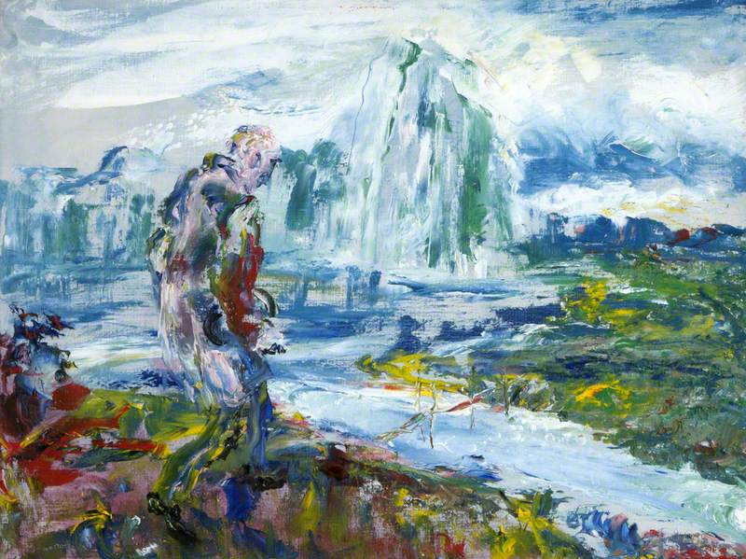

Jack B Yeats, *On Through the Silent Lands* (1951)

<http://www.bbc.co.uk/arts/yourpaintings/paintings/on-through-the-silent-lands-123207>

References and Further Reading:

Armstrong, G.A. (1990) *Samuel Beckett, W.B. Yeats and Jack Yeats: images and Words ,* Lewisburg PA: Bucknell University Press

Arnold, B. (1998) *Jack Yeats,* New Haven and London: Yale University Press

O’Malley, E. (1945) ‘The Paintings of Jack B. Yeats’, in *Sources in Irish Art: a reader,* ed. F. Cullen (2000) Cork: Cork University Press

Pyle, H. (1997) *Yeats: Portrait of an Artistic Family*, Dublin: National Gallery of Ireland

Scott, Y., ed. (2008) *Jack B. Yeats: Old and New Departures,* Dublin: Four Courts Press